HEALTH AI – SRS
Software Requirements Specification (SRS)
Field | Detail
Project Name | HEALTHCARE
Course | SENG 384 – Software Project III
Group Name | Karastana
Group Members | Tuna Deniz, Göktuğ Tabak, Oğuzhan Tarhan, Buğra Kara
Submission Date | 15/04/2026
Version | 1.0

Revision History
Date | Version | Change Description | Author
09/04/2026 | 1.0 | Initial version | Tuna Deniz

Table of Contents
Table of Contents 1
1. Introduction 1
1.1 Purpose 1
1.2 Scope 1
1.3 Definitions and Abbreviations 1
1.4 Intended Audience 1
2. Overall Description 1
2.1 Product Perspective 1
2.2 User Roles 1
2.3 Assumptions and Dependencies 1
2.4 Constraints 1
3. Functional Requirements 1
3.1 User Registration & Access Control 1
3.2 Post Management 1
3.3 Search & Matching 1
3.4 Meeting Request Workflow 1
3.5 Administrative Dashboard 1
3.6 Activity Logging & Audit Trail 1
4. Non-Functional Requirements 1
5. Use Cases 1
5.1 UC-01: Engineer Creates a Post 1
5.2 UC-02: Healthcare Professional Sends Meeting Request 1
5.3 UC-03: Admin Removes Inappropriate Post 1
5.4 UC-04: User Marks Partner Found 1
5.5 UC-05: Healthcare Professional Creates a Post 1
5.6 UC-06: User Registers to the Platform 1
6. Data Model 1
7. Interface Requirements 1
7.1 User Interface (UI) 1
7.2 External System Interfaces 1
8. Requirements Traceability Matrix 1
9. Appendices 1

1. Introduction

1.1 Purpose
This Software Requirements Specification (SRS) document defines the functional and non-functional requirements for the HEALTH AI Co-Creation & Innovation Platform. The document serves as the primary reference for the design, development, and testing phases of the project. It describes the system’s intended behavior, constraints, user roles, use cases, and data model in detail. This SRS is prepared based on the HEALTH AI project brief provided for the SENG 384 course.

1.2 Scope
The HEALTH AI platform is a secure, GDPR-compliant web application that enables structured partner discovery between healthcare professionals and engineers in the health-tech innovation domain. The platform allows users to create structured announcements describing their collaboration needs, discover potential partners through search and filtering, initiate first contact via a meeting request workflow with NDA acceptance, and schedule external meetings.
The platform does not provide financial transactions, contract management, medical advice, file-sharing or document repository functionality, project management features, or storage of patient data or confidential intellectual property.

1.3 Definitions and Abbreviations
Term | Definition
SRS | Software Requirements Specification
SDD | Software Design Document
RBAC | Role-Based Access Control
GDPR | General Data Protection Regulation
NDA | Non-Disclosure Agreement
WCAG | Web Content Accessibility Guidelines
JWT | JSON Web Token
API | Application Programming Interface
REST | Representational State Transfer
CRUD | Create, Read, Update, Delete
HTTPS | Hypertext Transfer Protocol Secure
Post | A structured announcement created by a user seeking collaboration partners
Meeting Request | A formal request sent by an interested user to the post owner to schedule an external meeting
Partner Found | A post status indicating that the post owner has found a suitable collaboration partner

1.4 Intended Audience
This document is intended for the SENG 384 course instructor and teaching assistants (for evaluation purposes), development team members (for implementation guidance), quality assurance and testing personnel (for verification and validation), and project stakeholders who need to understand the system requirements.

2. Overall Description

2.1 Product Perspective
Multidisciplinary innovation in healthcare technology requires rapid and structured access to complementary expertise. Engineers developing healthcare technologies need clinical domain knowledge, workflow understanding, validation processes, and ethical approval pathways to transform concepts into viable solutions. Conversely, healthcare professionals frequently generate compelling innovation ideas but lack the engineering competence and technical infrastructure to implement them effectively.
The current landscape forces innovators to depend largely on personal networks — an inefficient model that slows innovation and limits potential partnerships to those with existing connections. The HEALTH AI platform eliminates this randomness in interdisciplinary collaboration by providing structured announcement-based partner discovery, secure first-contact initiation, controlled disclosure of ideas, a transparent meeting workflow, and clear closure of partner requests.
HEALTH AI is fundamentally a user experience platform. The system must feel safe, professional, simple, structured, and trustworthy. Users must understand the platform’s purpose within 20 seconds and be able to post an announcement without confusion.

2.2 User Roles
Role | Description | Key Permissions
Engineer | A technical professional (e.g., software engineer, biomedical engineer) who registers on the platform to find healthcare domain expertise for their health-tech projects. | Create/edit/close posts; browse healthcare professional posts; send meeting requests; accept/decline meeting requests on own posts; manage own profile; express interest in posts
Healthcare Professional | A medical professional (e.g., doctor, nurse, clinical researcher) who registers on the platform to find engineering expertise or to offer clinical domain knowledge. | Create/edit/close posts; browse engineer posts; send meeting requests; accept/decline meeting requests on own posts; manage own profile; express interest in posts
Admin | A platform administrator responsible for overseeing platform operations, user management, and content moderation. | All standard user permissions; view/manage all users; suspend/deactivate accounts; view/filter/remove any post; access activity logs and statistics; export logs as CSV

2.3 Assumptions and Dependencies
It is assumed that all users possess a valid institutional .edu email address (e.g., .edu, .edu.tr). It is assumed that users have access to a modern web browser (Chrome, Firefox, Edge, Safari – latest versions) and a stable internet connection. External meeting platforms (Zoom, Microsoft Teams, Google Meet, etc.) are independently managed by users; the platform only facilitates scheduling. An external SMTP email service is required for sending verification emails and notifications. Users are expected to complete their profile after a quick initial registration to enable effective matching. The platform relies on honest self-declaration of roles; however, .edu email verification provides a basic trust layer. Fake .edu email addresses are a known risk; the system should implement additional verification measures (e.g., domain whitelist, manual admin approval for suspicious registrations).

2.4 Constraints
No patient data shall be stored on the platform at any time. No file uploads or document repository functionality shall be provided. No financial transactions or contract management shall be supported. No medical advice shall be provided through the platform. Registration is limited to institutional .edu email addresses only. Meetings are conducted externally; the platform does not host or record meetings. The platform facilitates first contact only; ongoing project collaboration tools are out of scope. NDA/confidentiality acceptance is required before initiating a meeting request conversation. Engineers shall not be able to view a directory or list of healthcare professionals (and vice versa); discovery happens only through posts.

3. Functional Requirements

3.1 User Registration & Access Control
ID | Requirement Description | Priority | Source
FR-01 | The system shall only allow registration with institutional .edu email addresses. Personal email providers (Gmail, Outlook, Yahoo, etc.) shall be rejected. | High | Brief 4.1
FR-02 | The system shall implement an email verification mechanism. A verification link shall be sent to the user’s registered email, and the account shall not be activated until the link is confirmed. | High | Brief 4.1
FR-03 | The user shall select a role during registration: Engineer or Healthcare Professional. The Admin role shall be assignable only by existing admins. | High | Brief 4.1
FR-04 | The system shall enforce Role-Based Access Control (RBAC) such that users can only access functionalities permitted for their assigned role. | High | Brief 4.1
FR-05 | The system shall provide a quick registration flow (email, password, role selection) followed by a separate profile completion step (name, institution, expertise areas, city, short bio). | Medium | Brief 4.1, Notes
FR-06 | The system shall allow users to create and manage a profile card containing their name, institution, expertise areas, city, and a short bio. This profile card shall be visible to other users when they view the user’s posts. | Medium | Notes
FR-07 | The system shall implement measures to mitigate fake .edu email registration (e.g., domain whitelist, suspicious registration flagging for admin review). | Medium | Notes
FR-08 | The system shall allow users to log out, terminating their active session. | High | Brief 4.1
FR-09 | Engineers shall not be able to view a list/directory of healthcare professionals. Discovery shall occur only through posts. | High | Notes

3.2 Post Management
ID | Requirement Description | Priority | Source
FR-10 | The system shall allow authenticated users to create a new post containing: Title, Working Domain, Short Explanation, Required Expertise (medical or engineering), Project Stage, Level of Commitment, Estimated Collaboration Type (advisor / co-founder / research partner), Confidentiality Level (public short pitch / details discussed in meeting only), Expiry Date, Country, and City. | High | Brief 4.2
FR-11 | The system shall allow post owners to edit their posts while the post is in Draft or Active status. | High | Brief 4.2
FR-12 | The system shall allow post owners to change the post status to “Partner Found”, which closes the post and prevents new meeting requests. | High | Brief 4.2
FR-13 | The system shall support the following post lifecycle states: Draft, Active, Meeting Scheduled, Partner Found (Closed), and Expired. | High | Brief 4.2
FR-14 | The system shall allow users to save a post as Draft before publishing. Draft posts shall not be visible to other users. | Medium | Brief 4.2
FR-15 | The system shall automatically transition a post to “Expired” status when its expiry date is reached. | Medium | Brief 4.2
FR-16 | The system shall provide an auto-close option that automatically closes a post after a specified condition is met (e.g., expiry date). | Low | Brief 4.2
FR-17 | The system shall NOT allow users to upload technical documentation, patient data, or any files to the platform. | High | Brief 4.2
FR-18 | Post creation shall be achievable in 3 steps or fewer (create → fill fields → publish). | High | Brief 5.4
FR-19 | For engineer posts, the form shall include a field for “High-level idea (without revealing sensitive details)”. For healthcare professional posts, the form shall include a field for “Desired technical expertise”. | Medium | Brief 3.1, 3.2
FR-19a | The system shall display the most recent posts at the top of the listing (newest first). | Medium | Notes

3.3 Search & Matching
ID | Requirement Description | Priority | Source
FR-20 | The system shall allow users to filter posts by: Domain, Required Expertise, City, Country, Project Stage, and Status. | High | Brief 4.3
FR-21 | The system shall highlight city-based matches to help users discover potential partners in the same geographic area. | Medium | Brief 4.3
FR-22 | The system shall provide a match explanation for relevant results (e.g., shared expertise tags, same city). | Low | Brief 4.3
FR-23 | Search results shall be returned within 1.5 seconds. | High | Brief 5.3
FR-24 | Healthcare professionals shall be able to browse and filter engineer posts. Engineers shall be able to browse and filter healthcare professional posts. | High | Brief 3.1, 3.2
FR-25 | During registration or profile completion, healthcare professionals shall be able to specify their interest areas; the system may use these to suggest relevant posts. | Low | Notes

3.4 Meeting Request Workflow
ID | Requirement Description | Priority | Source
FR-30 | The system shall allow an interested user to send a meeting request to a post owner. The meeting request shall include a short message explaining the user’s interest and relevant experience. | High | Brief 4.4
FR-31 | Before sending a meeting request, the system shall require the requesting user to accept a confidentiality/NDA agreement (e.g., “Conversations and shared information are your responsibility”). | High | Brief 4.4, Notes
FR-32 | The post owner shall be able to accept or decline a meeting request. | High | Brief 4.4
FR-33 | Upon acceptance, the post owner shall be able to propose meeting time slots (date and time). The requesting user shall be able to select from the proposed time slots. | High | Brief 4.4
FR-34 | The system shall allow either party to cancel a meeting request before the meeting occurs. | Medium | Brief 4.4
FR-35 | Meetings shall occur externally (Zoom, Teams, etc.). The platform shall not host, record, or store any meeting content. | High | Brief 4.4
FR-36 | Sending a meeting request shall be achievable in under 30 seconds. | High | Brief 5.4
FR-37 | The system shall provide a chat/message box within the meeting request context for users to coordinate external meeting details (e.g., sharing a Zoom link). | Medium | Notes
FR-38 | The system shall send email notifications to the post owner when a new meeting request is received, and to the requester when their request is accepted/declined. | High | Notes

3.5 Administrative Dashboard
ID | Requirement Description | Priority | Source
FR-40 | The admin dashboard shall be accessible only to users with the Admin role. | High | Brief 4.5
FR-41 | Admins shall be able to view all posts on the platform with filtering by city, domain, and status. | High | Brief 4.5.1
FR-42 | Admins shall be able to remove inappropriate posts from the platform. | High | Brief 4.5.1
FR-43 | Admins shall be able to view the lifecycle history of any post (status transitions with timestamps). | Medium | Brief 4.5.1
FR-44 | Admins shall be able to view platform-wide statistics (e.g., total posts, active posts, meetings scheduled, partners found). | Medium | Brief 4.5.1
FR-45 | Admins shall be able to view all registered users with filtering by role. | High | Brief 4.5.2
FR-46 | Admins shall be able to view profile completeness for each user. | Low | Brief 4.5.2
FR-47 | Admins shall be able to suspend or deactivate user accounts. | High | Brief 4.5.2
FR-48 | Admins shall be able to view activity metrics per user (e.g., number of posts, meeting requests sent/received). | Medium | Brief 4.5.2

3.6 Activity Logging & Audit Trail
ID | Requirement Description | Priority | Source
FR-50 | The system shall log the following events: login, logout, failed login attempts, post creation, post editing, post closure, meeting request sent/accepted/declined/cancelled, admin actions (post removal, user suspension), and security events. | High | Brief 4.6.1
FR-51 | Each log entry shall contain: Timestamp, User ID, Role, Action Type, Target Entity, and Result Status. IP address logging shall be optional and GDPR-compliant. | High | Brief 4.6.2
FR-52 | Logs shall not contain any patient data. Data minimization principles shall be applied. | High | Brief 4.6.3
FR-53 | Logs shall be tamper-resistant and stored with a defined retention period of 24 months. | Medium | Brief 4.6.3
FR-54 | Log access shall be restricted to Admin users only. | High | Brief 4.6.3
FR-55 | The admin log dashboard shall allow filtering logs by user, date range, and action type. | High | Brief 4.6.4
FR-56 | Admins shall be able to export filtered logs in CSV format. | Medium | Brief 4.6.4
FR-57 | The system should support anomaly pattern detection in logs (e.g., excessive failed login attempts, unusual activity spikes). | Low | Brief 4.6.4

4. Non-Functional Requirements
ID | Requirement | Metric / Target | Category
NFR-01 | Search results shall be returned within a specified time. | < 1.5 seconds | Performance
NFR-02 | Page load time shall not exceed a specified threshold. | < 3 seconds | Performance
NFR-03 | The system shall support a specified number of concurrent users without performance degradation. | 1000 concurrent users | Performance
NFR-04 | All communication between client and server shall use HTTPS. | HTTPS enforced on all endpoints | Security
NFR-05 | User passwords shall be stored using a strong, salted hashing algorithm. | bcrypt or argon2 | Security
NFR-06 | The system shall implement secure session management with automatic session timeout after inactivity. | Timeout after 30 min | Security
NFR-07 | The system shall implement rate limiting on authentication endpoints to prevent brute-force attacks. | Max 10 failed login attempts per 15 min per IP | Security
NFR-08 | The system shall implement anti-bot protection on registration and login forms. | CAPTCHA or equivalent | Security
NFR-09 | The system shall collect only the minimum data necessary for its functionality (data minimization). | GDPR Art. 5(1)(c) | GDPR / Privacy
NFR-10 | Users shall have the right to delete their account and all associated personal data permanently. | Full deletion within 72h | GDPR / Privacy
NFR-11 | Users shall be able to export their personal data in a portable, machine-readable format. | JSON or CSV export | GDPR / Privacy
NFR-12 | The platform shall display a clear privacy policy explaining data collection, usage, and retention. | Accessible from registration and footer | GDPR / Privacy
NFR-13 | No patient data shall be stored on the platform at any point. | Zero patient data records | GDPR / Privacy
NFR-14 | A new user shall be able to understand the platform’s purpose within 20 seconds of landing on the homepage. | Usability testing target | Usability
NFR-15 | Post creation shall be completable in 3 steps or fewer. | ≤ 3 steps | Usability
NFR-16 | Posting an announcement shall take less than 3 minutes from start to publish. | < 3 minutes | Usability
NFR-17 | Sending a meeting request shall take less than 30 seconds. | < 30 seconds | Usability
NFR-18 | The platform shall use plain, jargon-free language. Tooltips shall be provided for terms like IP, NDA. | All UI text reviewed | Usability
NFR-19 | Clear, color-coded status indicators shall be used for post lifecycle states. | Distinct colors per status | Usability
NFR-20 | The platform shall comply with WCAG 2.1 Level AA accessibility guidelines. | WCAG 2.1 AA | Accessibility
NFR-21 | The platform shall be fully responsive and functional on mobile devices, tablets, and desktops. | Min viewport: 320px | Accessibility

5. Use Cases

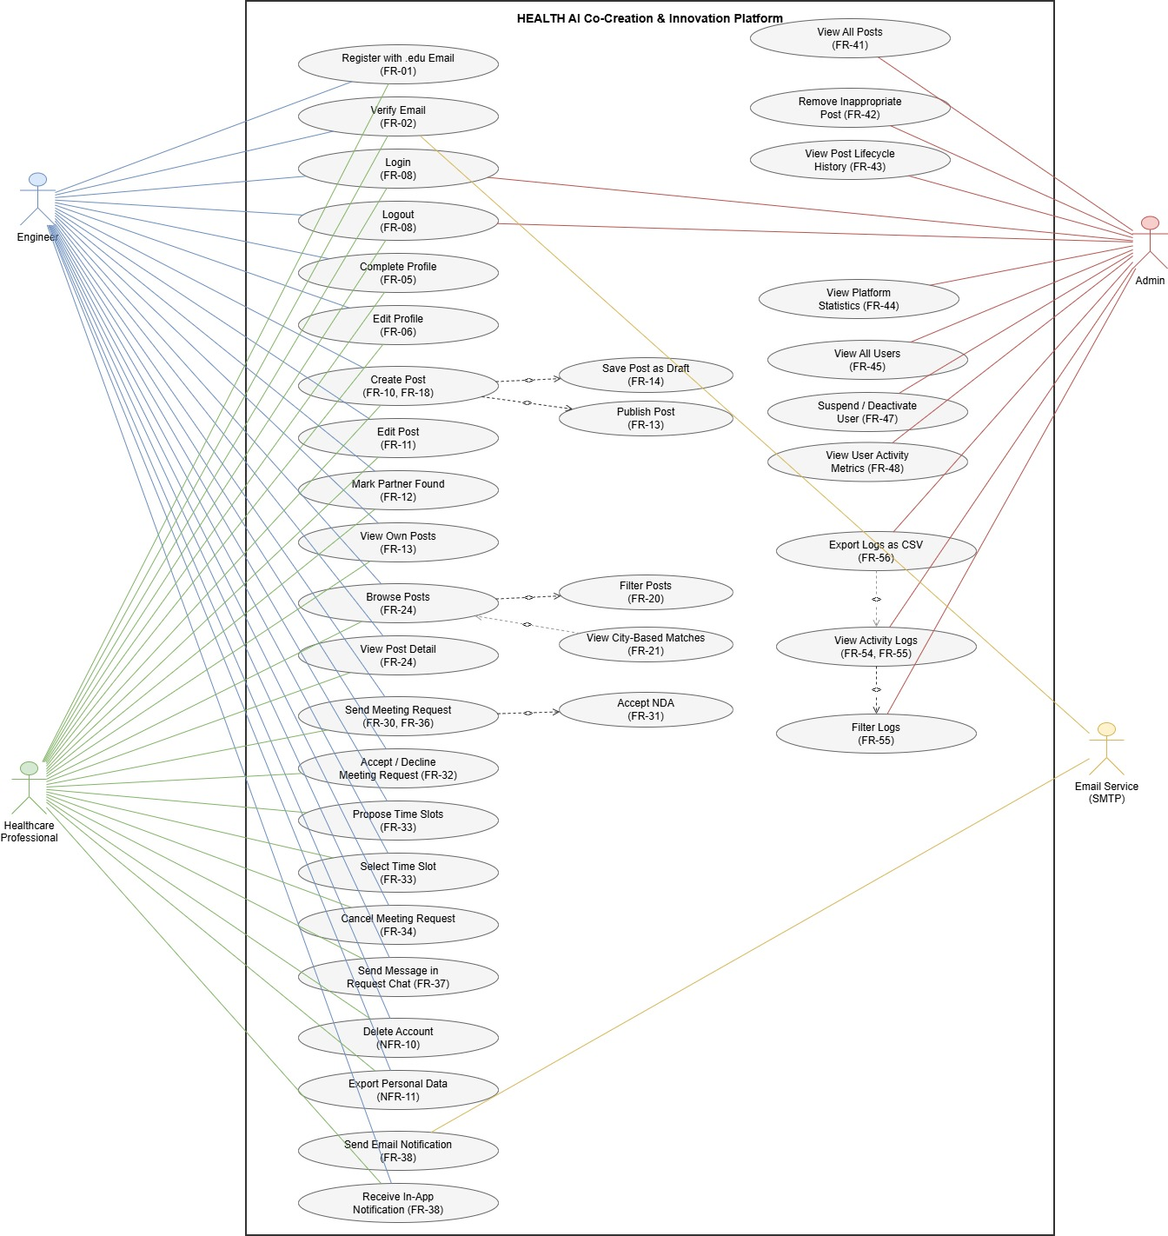

5.1 UC-01: Engineer Creates a Post
Field | Detail
Name | UC-01: Engineer Creates a Post
Actor(s) | Engineer
Precondition | The engineer must be logged in and have a verified account.
Main Flow | 1. The engineer clicks the “+” or “New Post” button on the Dashboard. 2. The system displays the post creation form with fields: Title, Working Domain, Short Explanation, Required Healthcare Expertise, Project Stage, Level of Commitment, High-level Idea, Estimated Collaboration Type, Confidentiality Level, Expiry Date, Country, City. 3. The engineer fills in all required fields. 4. The engineer selects “Publish” or “Save as Draft”. 5. If “Publish” is selected, the system validates the form, saves the post with “Active” status, and displays it on the public feed.
Postcondition | The post is saved in the system. If published, it is visible to healthcare professionals on the platform.
Alternative Flow | 3a. If a required field is left blank, the system highlights the missing field and displays an error message. 4a. If “Save as Draft” is selected, the post is saved with “Draft” status and is only visible to the owner.

5.2 UC-02: Healthcare Professional Sends Meeting Request
Field | Detail
Name | UC-02: Healthcare Professional Sends Meeting Request
Actor(s) | Healthcare Professional
Precondition | The healthcare professional must be logged in. The target post must be in “Active” status.
Main Flow | 1. The healthcare professional browses or filters the post feed. 2. Clicks on a post to view details. 3. Clicks “Express Interest” / “Request Meeting”. 4. The system presents the NDA/Confidentiality acceptance screen. 5. Reads and accepts the NDA terms. 6. Writes a short message explaining interest and relevant experience. 7. Clicks “Send Request”. 8. The system saves the meeting request with “Pending” status and sends an email notification to the post owner.
Postcondition | A meeting request is created and the post owner is notified via email and in-app notification.
Alternative Flow | 5a. If the NDA is declined, the process is cancelled. 7a. If the message field is empty, the system prompts the user to provide a message.

5.3 UC-03: Admin Removes Inappropriate Post
Field | Detail
Name | UC-03: Admin Removes Inappropriate Post
Actor(s) | Admin
Precondition | The admin must be logged in with Admin role. The target post exists on the platform.
Main Flow | 1. The admin navigates to Admin Panel → Posts. 2. Browses or filters posts (by status, domain, date). 3. Clicks on a post to view details and lifecycle history. 4. Determines the post violates platform guidelines. 5. Clicks “Remove Post”. 6. The system prompts confirmation and optionally a reason. 7. The admin confirms. 8. The system marks the post as removed, logs the action, and notifies the post owner.
Postcondition | The post is removed from public view. An activity log entry is created. The post owner is notified.
Alternative Flow | 7a. If the admin cancels confirmation, the post remains unchanged.

5.4 UC-04: User Marks Partner Found
Field | Detail
Name | UC-04: User Marks Partner Found
Actor(s) | Engineer or Healthcare Professional (post owner)
Precondition | The user must be logged in and own the post. The post must be in “Active” or “Meeting Scheduled” status.
Main Flow | 1. The user navigates to their post (from Dashboard or “My Posts”). 2. Clicks the “Mark as Partner Found” button. 3. The system displays a confirmation dialog. 4. The user confirms. 5. The system updates the post status to “Partner Found (Closed)”. 6. The post no longer accepts new meeting requests. 7. All pending meeting requests are notified that the post has been closed.
Postcondition | The post status is “Partner Found (Closed)”. No new meeting requests can be submitted.
Alternative Flow | 4a. If the user cancels confirmation, the post status remains unchanged.

5.5 UC-05: Healthcare Professional Creates a Post
Field | Detail
Name | UC-05: Healthcare Professional Creates a Post
Actor(s) | Healthcare Professional
Precondition | The healthcare professional must be logged in and have a verified account.
Main Flow | 1. Clicks the “+” or “New Post” button on the Dashboard. 2. The system displays the post creation form with fields: Title, Medical Field, Short Explanation, Desired Technical Expertise, Project Stage, Level of Commitment, Estimated Collaboration Type, Confidentiality Level, Expiry Date, Country, City. 3. Fills in all required fields. 4. Selects “Publish” or “Save as Draft”. 5. If “Publish” is selected, the system validates and saves with “Active” status.
Postcondition | The post is saved. If published, it is visible to engineers on the platform.
Alternative Flow | 3a. If a required field is left blank, the system highlights the missing field. 4a. If “Save as Draft” is selected, the post is saved with “Draft” status.

5.6 UC-06: User Registers to the Platform
Field | Detail
Name | UC-06: User Registers to the Platform
Actor(s) | Engineer or Healthcare Professional
Precondition | The user has a valid institutional .edu email address.
Main Flow | 1. Navigates to the platform homepage. 2. Clicks “Register”. 3. Enters .edu email address and creates a password. 4. Selects role (Engineer or Healthcare Professional). 5. Clicks “Register”. 6. The system validates the email domain. 7. Sends a verification email. 8. The user clicks the verification link. 9. Account is activated. Redirected to profile completion. 10. Fills in profile details (name, institution, expertise areas, city, short bio).
Postcondition | The user account is created, verified, and the profile is completed.
Alternative Flow | 6a. If the email is not .edu, registration is rejected. 8a. If the verification link expired, the user can request a new one. 10a. Profile completion can be skipped but matching effectiveness is reduced.

6. Data Model
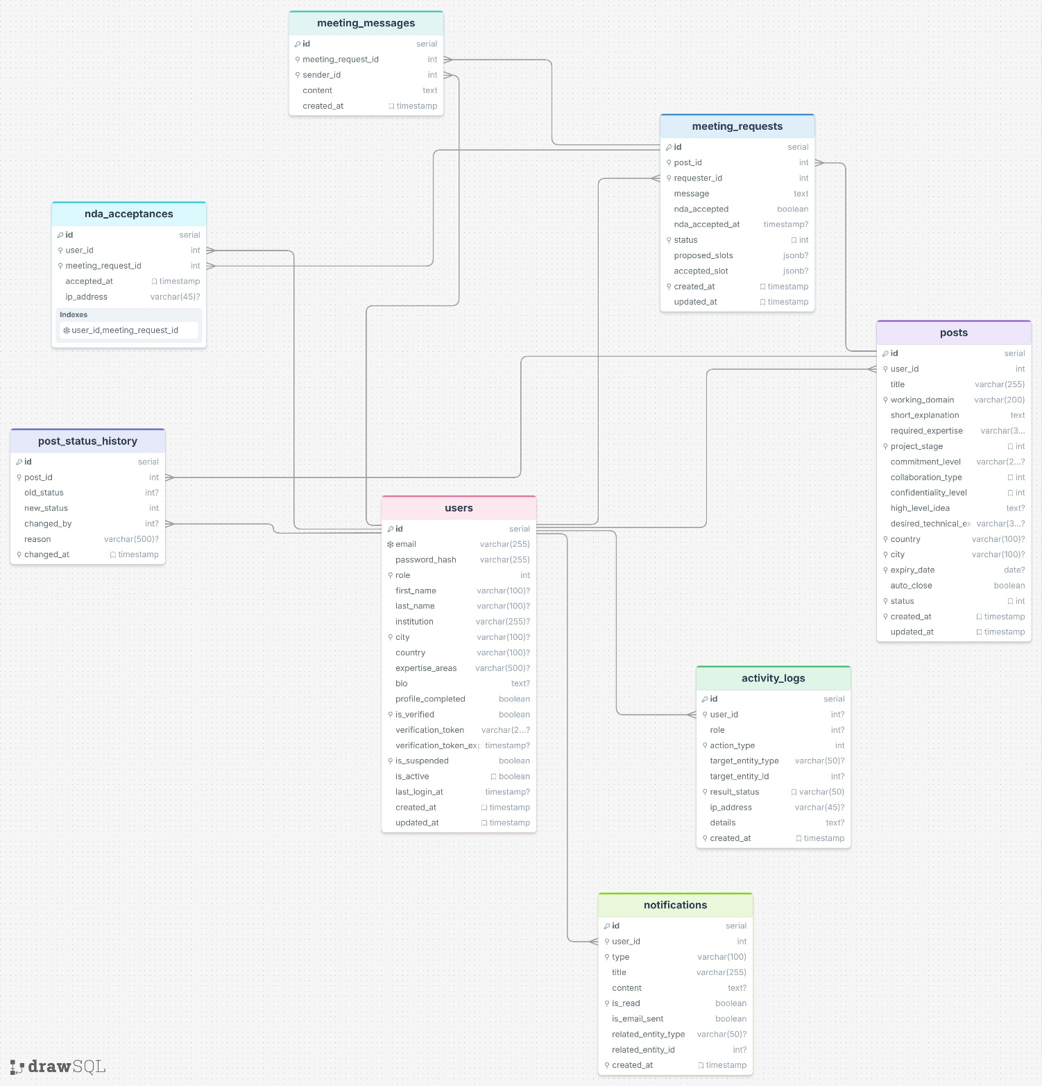

Entity | Key Fields | Relationships
User | id (PK), email (UNIQUE, .edu check), password_hash, role (engineer / healthcare / admin), first_name, last_name, institution, city, country, expertise_areas, bio, profile_completed, is_verified, is_suspended, is_active, created_at, updated_at | One User → Many Posts; One User → Many MeetingRequests (as requester); One User → Many ActivityLogs; One User → Many Notifications
Post | id (PK), user_id (FK → User), title, working_domain, short_explanation, required_expertise, project_stage, commitment_level, collaboration_type, confidentiality_level, high_level_idea, desired_technical_expertise, expiry_date, auto_close, country, city, status (draft / active / meeting_scheduled / partner_found / expired), created_at, updated_at | One Post → One User (owner); One Post → Many MeetingRequests; One Post → Many PostStatusHistory
PostStatusHistory | id (PK), post_id (FK → Post), old_status, new_status, changed_by (FK → User), reason, changed_at | One PostStatusHistory → One Post; One PostStatusHistory → One User
MeetingRequest | id (PK), post_id (FK → Post), requester_id (FK → User), message, status (pending / accepted / declined / scheduled / completed / cancelled), nda_accepted, nda_accepted_at, proposed_slots (JSON), accepted_slot, created_at, updated_at | One MeetingRequest → One Post; One MeetingRequest → One User (requester); One MeetingRequest → Many MeetingMessages
MeetingMessage | id (PK), meeting_request_id (FK → MeetingRequest), sender_id (FK → User), content, created_at | One MeetingMessage → One MeetingRequest; One MeetingMessage → One User (sender)
NDAAcceptance | id (PK), user_id (FK → User), meeting_request_id (FK → MeetingRequest), accepted_at, ip_address (optional) | One NDAAcceptance → One User; One NDAAcceptance → One MeetingRequest
Notification | id (PK), user_id (FK → User), type, title, content, is_read, is_email_sent, related_entity_type, related_entity_id, created_at | One Notification → One User
ActivityLog | id (PK), user_id (FK → User), role, action_type, target_entity_type, target_entity_id, result_status, ip_address (optional, GDPR-compliant), details, created_at | One ActivityLog → One User

7. Interface Requirements

7.1 User Interface (UI)
The platform UI shall be clean, minimal, and focused on task completion with minimum clicks. The following screens are required:
Screen | Description | Access
Landing Page | Platform introduction explaining the purpose clearly within 20 seconds. Contains “Register” and “Login” buttons. | Public
Registration Page | Email input (.edu validation), password creation, role selection. Minimal fields for quick registration. | Public
Login Page | Email and password input. Link to “Forgot Password” and “Resend Verification Email”. | Public
Dashboard | Main screen after login. Shows a feed of relevant posts (newest first), a prominent “+” or “New Post” button, filter/search bar, and notification indicator. | Authenticated
Post Creation Form | A step-based form (≤ 3 steps) with all required post fields. Role-specific fields shown based on user type. | Authenticated
Post Detail Page | Full post information, post owner’s profile card, status badge, and “Express Interest” / “Request Meeting” button. | Authenticated
My Posts | Lists all posts created by the logged-in user with status badges. Allows editing and status changes. | Authenticated
Meeting Request View | Meeting request details, requester’s profile card, message, NDA status, proposed time slots, and message box. | Authenticated
Profile Page | View and edit profile information. Account deletion and data export options. | Authenticated
Admin Panel – Posts | Table/list of all posts with filters (city, domain, status, date). Actions: view details, remove post. | Admin
Admin Panel – Users | Table/list of all users with filters (role, status). Actions: view profile, suspend/deactivate. | Admin
Admin Panel – Logs | Searchable and filterable activity log table. CSV export button. | Admin
Admin Panel – Statistics | Platform-wide metrics: total users, total posts, active posts, meetings scheduled, partners found. | Admin
[VISUAL: En az 3-4 ana ekran için wireframe / mockup veya ekran görüntüsü buraya eklenecek (Registration, Dashboard, Post Creation, Post Detail + Meeting Request).]
Key UI Principles:
Simple, minimal screens with minimum clicks to achieve goals. No cluttered layouts. The “+” / “New Post” button must be immediately visible on the dashboard upon login. Newest announcements displayed at the top. Clear navigation flow. No unnecessary images or decorative elements. Color-coded status badges: Gray = Draft, Green = Active, Blue = Meeting Scheduled, Purple = Partner Found, Red = Expired.

7.2 External System Interfaces
External System | Purpose | Integration Method
SMTP Email Service (e.g., SendGrid, AWS SES, Mailgun) | Sending verification emails, notification emails (meeting requests, status changes, account activity) | SMTP API / REST API
External Meeting Platforms (Zoom, Teams, Google Meet) | Users share meeting links manually via the in-platform message box. No direct integration. | Link sharing only (no API integration)

8. Requirements Traceability Matrix
Req. ID | Requirement Summary | Source (Brief) | Related Use Case
FR-01 | .edu email restriction | Brief 4.1 | UC-06
FR-02 | Email verification mechanism | Brief 4.1 | UC-06
FR-03 | Role selection during registration | Brief 4.1 | UC-06
FR-04 | Role-Based Access Control (RBAC) | Brief 4.1 | All UCs
FR-05 | Quick registration + profile completion | Brief 4.1, Notes | UC-06
FR-06 | User profile card | Notes | UC-01, UC-02, UC-05
FR-07 | Fake .edu email mitigation | Notes | UC-06
FR-08 | Logout functionality | Brief 4.1 | All UCs
FR-09 | No user directory browsing | Notes | UC-02
FR-10 | Post creation with all fields | Brief 4.2 | UC-01, UC-05
FR-11 | Post editing (Draft/Active) | Brief 4.2 | UC-01, UC-05
FR-12 | Mark post as Partner Found | Brief 4.2 | UC-04
FR-13 | Post lifecycle states | Brief 4.2 | UC-01, UC-04, UC-05
FR-14 | Save as Draft | Brief 4.2 | UC-01, UC-05
FR-15 | Auto-expiry on expiry date | Brief 4.2 | —
FR-16 | Auto-close option | Brief 4.2 | —
FR-17 | No file uploads | Brief 4.2 | All UCs
FR-18 | Post creation ≤ 3 steps | Brief 5.4 | UC-01, UC-05
FR-19 | Role-specific post form fields | Brief 3.1, 3.2 | UC-01, UC-05
FR-19a | Newest posts first | Notes | UC-02
FR-20 | Search/filter by domain, city, etc. | Brief 4.3 | UC-02
FR-21 | City-based match highlighting | Brief 4.3 | UC-02
FR-22 | Match explanation | Brief 4.3 | UC-02
FR-23 | Search < 1.5 sec | Brief 5.3 | UC-02
FR-24 | Cross-role post browsing | Brief 3.1, 3.2 | UC-02
FR-25 | Interest area-based suggestions | Notes | UC-02
FR-30 | Meeting request with message | Brief 4.4 | UC-02
FR-31 | NDA acceptance before request | Brief 4.4, Notes | UC-02
FR-32 | Accept/decline meeting request | Brief 4.4 | UC-02
FR-33 | Time slot proposal and selection | Brief 4.4 | UC-02
FR-34 | Cancel meeting request | Brief 4.4 | UC-02
FR-35 | External meetings only | Brief 4.4 | UC-02
FR-36 | Meeting request < 30 sec | Brief 5.4 | UC-02
FR-37 | Message box for coordination | Notes | UC-02
FR-38 | Email notifications for requests | Notes | UC-02
FR-40 | Admin dashboard access control | Brief 4.5 | UC-03
FR-41 | Admin view/filter all posts | Brief 4.5.1 | UC-03
FR-42 | Admin remove post | Brief 4.5.1 | UC-03
FR-43 | Post lifecycle history | Brief 4.5.1 | UC-03
FR-44 | Platform statistics | Brief 4.5.1 | —
FR-45 | Admin view/filter all users | Brief 4.5.2 | —
FR-46 | Profile completeness view | Brief 4.5.2 | —
FR-47 | Suspend/deactivate accounts | Brief 4.5.2 | —
FR-48 | User activity metrics | Brief 4.5.2 | —
FR-50 | Comprehensive event logging | Brief 4.6.1 | All UCs
FR-51 | Log data fields | Brief 4.6.2 | All UCs
FR-52 | No patient data in logs | Brief 4.6.3 | All UCs
FR-53 | Tamper-resistant logs, 24-month retention | Brief 4.6.3 | —
FR-54 | Admin-only log access | Brief 4.6.3 | UC-03
FR-55 | Filter logs by user/date/action | Brief 4.6.4 | UC-03
FR-56 | Export logs as CSV | Brief 4.6.4 | UC-03
FR-57 | Anomaly pattern detection | Brief 4.6.4 | —

9. Appendices
[Appendix A: Use Case Diagram ]
[Appendix B: Wireframes / Mockups ]
[Appendix C: ER Diagram ]

